**ASSIGNMENT 1**

**INTRODUCTION:**

The Tips dataset contains information about tips received by waitstaff in a restaurant. The dataset includes features such as total bill amount, tip amount, gender of the person paying the bill, whether the person is a smoker, day of the week, time of day, and size of the party.

**SEX VS. SMOKER**:

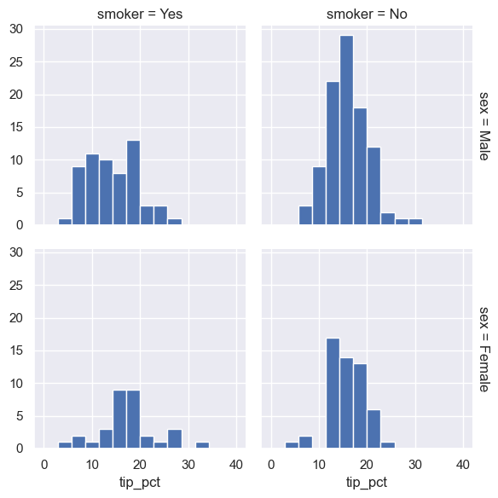

This faceted histogram shows that non-smokers generally tip more consistently around 15-20%, while smokers show more variability in tipping. Female non-smokers tend to tip slightly less than male non-smokers.

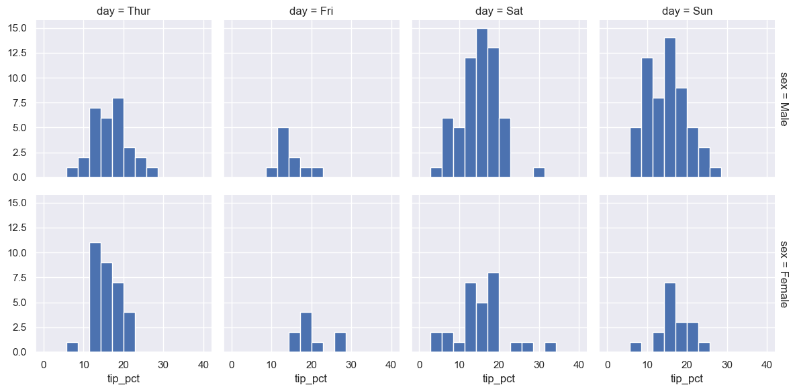**SEX VS. DAY:**

This faceted histogram visualizes that tips are generally higher on weekends (Sat and Sun) with a consistent range between genders, while weekdays (Thur and Fri) show smaller peaks and variability in tipping behavior.

**SEX VS. TIME:**

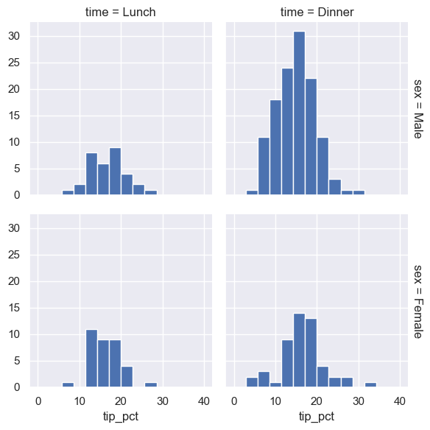

This faceted histogram shows that tips are more concentrated and higher during dinner, while lunch shows a smaller range and lower frequencies. Gender differences in tipping behavior are minimal for both time periods.

**SEX VS. SIZE:**

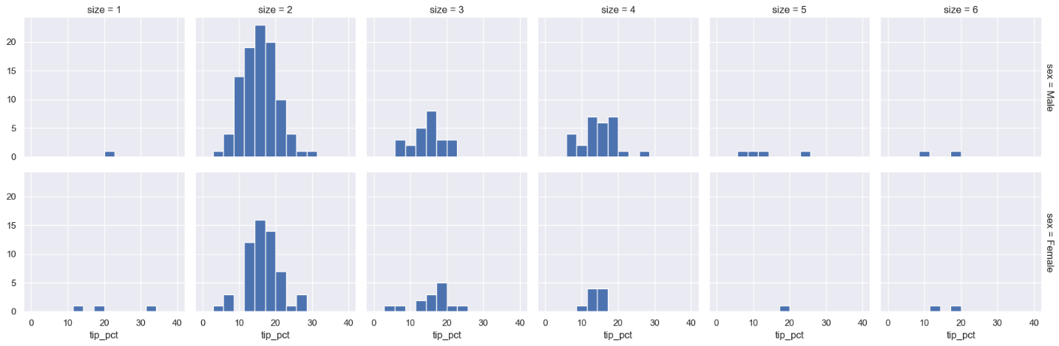The distributions are generally right-skewed, suggesting a larger proportion of lower tips. As table size increases, the distribution of tip percentages appears to become more spread out, indicating greater variability in tipping behavior for larger groups.

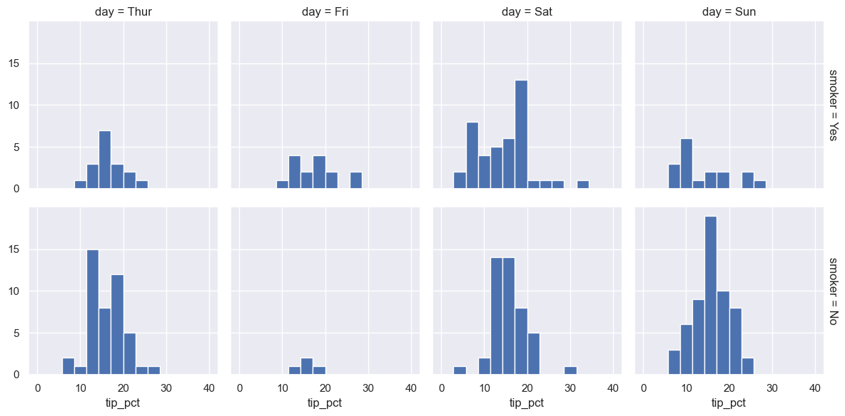**SMOKER VS. DAY:**



The distributions are generally skewed to the right, with a higher concentration of lower tip percentages. There appears to be some variation in tip patterns across days and smoking status.

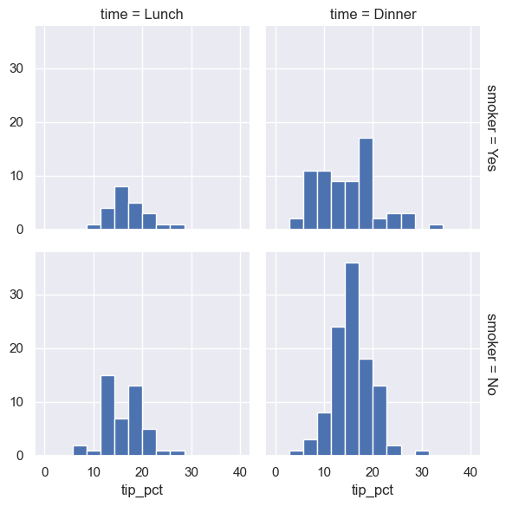**SMOKER VS. TIME:**

The distributions are generally skewed to the right, with a higher concentration of lower tip percentages. Tip percentages appear to vary between lunch and dinner, and there might be differences in tipping behavior between smokers and non-smokers.

**SMOKER VS. SIZE:**

The distributions are generally skewed to the right, with a higher concentration of lower tip percentages. As the table size increases, the distribution of tip percentages appears to become more spread out, suggesting greater variability in tipping behavior for larger groups.

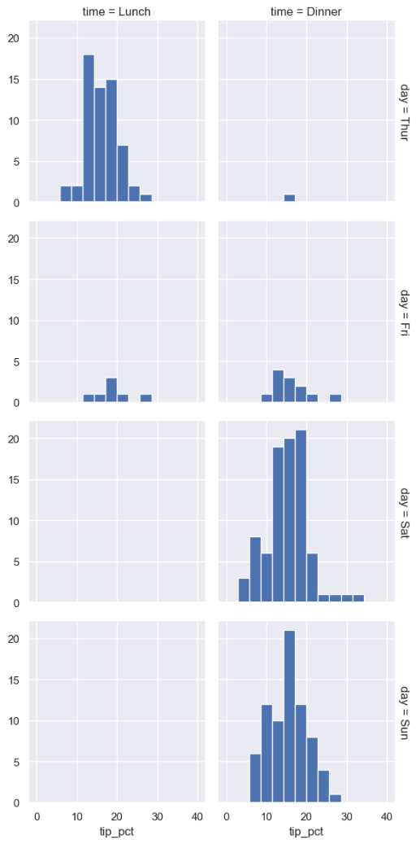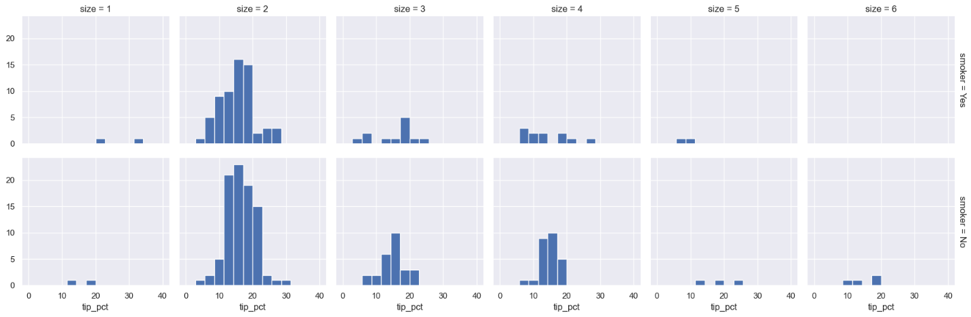**DAY VS. TIME:**

The distributions are generally right-skewed, indicating that a larger proportion of tips fall within the lower percentage range. Tip percentages appear to vary between lunch and dinner, and there might be differences in tipping behavior between smokers and non-smokers.

**DAY VS. SIZE:**

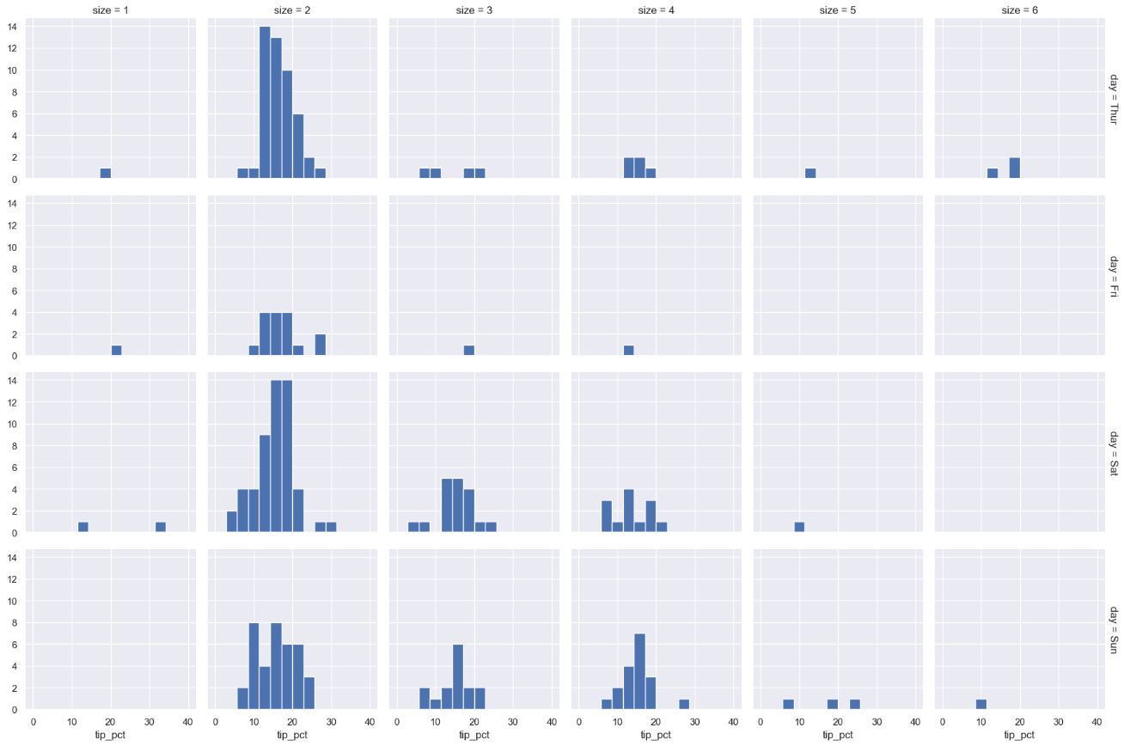

The distributions are generally right-skewed, indicating that a larger proportion of tips fall within the lower percentage range. As the table size increases, the distribution of tip percentages appears to become more spread out, indicating greater variability in tipping behavior for larger groups.

**TIME VS. SIZE:**

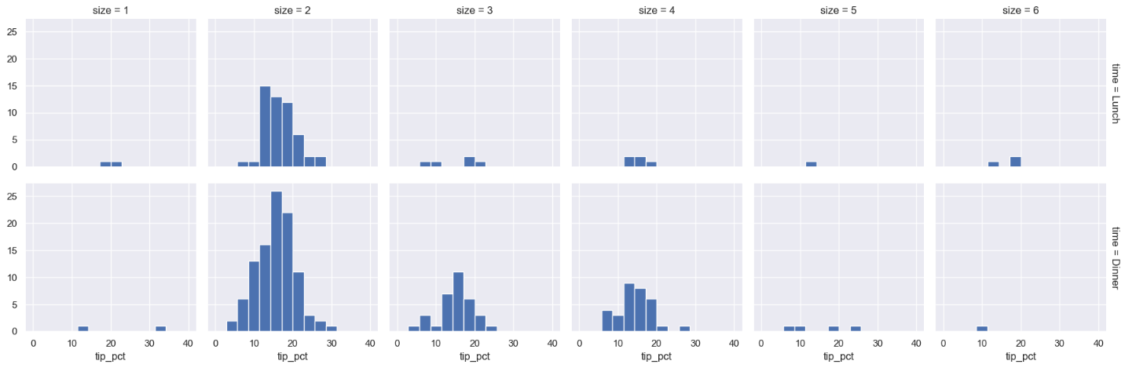

The distributions are generally right-skewed, indicating that a larger proportion of tips fall within the lower percentage range. As the table size increases, the distribution of tip percentages appears to become more spread out, indicating greater variability in tipping behavior for larger groups.